Search and Rescue Zumo Assignment Report
This assignment consists of several different objectives to alter and code a Zumo robot so that it can successfully navigate around a set route looking for people which are represented as objects in the route. These people or obstacles could be in a room a corridor which the Zumo would need to identify, both of which would be found using ultra-sonic sensors.
First task was to get the Zumo robot to be driven down the corridor using the W, A, S, D keys and the space bar to stop. After going over this in one of the tutorials I adopted the code from that tutorial to make it work for my assignment and I got the keys and buttons to work. I was then able to get the Zumo navigating around the route using these buttons. I found this task very straight forward and therefore was able to complete it quickly and move onto the other tasks.
To keep the Zumo robot within the corridor walls, I looked at one of the examples named border detect which helped me understand how the Zumo robot behaves and how the sensors function. This helped me greatly on how to get the values from the sensor and also how to use the sensors properly. It also helped me work out the values at different places on my route/ track so I could make the Zumo robot react exactly how I want it to and know the edge of the corridor and hence turn away from the edge. I made use of the sensors by hard coding that if the left most two sensors found a wall the Zumo would reverse slightly before turning to the right and carrying and if the right most two sensors detected the border the robot will reverse and turn left. I also used this detecting logic to make the robot stop when the middle sensors detect the border hence stating a wall is reached.
Task 3 was also fairly straight forward like task 1 and 2, I completed this task is by adapting the code I already had from task 2. After managing to stop the Zumo robot once it reached a wall I coded so that once it has been turned away from the wall at a key press the Zumo robot will start driving automatically by itself along the corridor. This was done by also adapting the code from the border detect example, I figured out how to do calibration on the robot sensors therefore I didn’t have to use any set values, I did this by using a for loop to set the values for the 5 different sensors. After doing this the detection of the borders and the walls became simple as it recognises that the borders are a different colour and hence I can make the robot to react how I want it to.
To make the Zumo robot go into a room I had to select buttons in the GUI when outside a room. I had 2 different buttons for scanning a room, one for a room on the left and one for a room on the right. This sets a Boolean for finding a room to true which makes the Arduino go through some other code. Then the Zumo is driven into the room and the direction in which the robot turned in is recorded so it is known what side of the corridor the room is on. There are also 2 global room counter variable that increments each time a left and right room is found and assigns a number to each room. The room is then scanned and for this an ultrasonic sensor is used. I looked at the new ping example in the new ping library, this helped me a lot to understand how to use the sensor to pick up what is in front of it. I first set the Zumo to turn then I use a for loop to scan several times for an object. I turn the robot one way then starts the scan then similarly the other way too. If an object is found it prints the corridor id and room number. If no object is found then an appropriate message is also printed.
I found task 4 much more challenging than the previous tasks and hence it took a lot more time to do task 4 than it did for task 1,2, and 3. I came across several different problems while trying to complete each section of part 4. In part a I found the scanning from the ultrasonic sensor to be difficult, mainly because it was being inconsistent and after a while I realized that my program was not efficient which maybe affecting the ability for the sensor to scan objects another problem I came across is displaying which corridor and room a certain object is in, but with correct placement of the serial.println I solved this issue. 4b was also difficult because I had to tell the robot that it has reached the end of a robot I did this by using several loops and I also found incrementing the corridor count difficult to complete. 4c was very difficult and much more challenging than any other tasks, I researched for ideas to help me complete this task and attempted to get this working.
The ultrasonic sensor also scans while the Zumo robot is just driving around normally. If it finds an object of some kind it stops just before reaching the object and sends and appropriate message to the GUI.
Task 5 was very difficult and after attempting it I came across lots of problems, after researching I was able to find a few solutions but I was unable to get the robot to find an optimal route back to the start, I started coding for this task and decided that using millis timer was a good idea so I can time the duration of each corridor and hence find an optimal route, but due to the shortage of time I was not able to get this working.
I also implemented a few extra functionality on my program.
- I got my Zumo robot to do sensor calibration and hence I didn’t have to use QTRTHRESHOLD.
- Due to sensor calibration my Zumo robot works well in non-desirable conditions like colored floor and darker lighting conditions.
- The Zumo robot automatically detects if any object is in a corridor or anywhere while it’s driving around. It detects the object and stops just before and sends appropriate messages to the GUI.
- There is an object count in my program that counts the number of objects detected by the Zumo robot and this is done by incrementing after finding every object.
- The buzzer and sound is used several times in my program, such as when sensor calibrating, finding an object etc.
- A well designed and aesthetically pleasing GUI is delivered with easy to use buttons and a good color scheme to make it easier to control the Zumo robot.
- Several different buttons on the GUI which do different important things, such as an object button to show how many objects have been detected at any certain moment and an end button which terminates the program and hence disabling the Zumo robot. Also a clear text button to clear any existing messages in the text area.

I have also attached 4 very short videos which show my Zumo robot working in different ways.
- calibrationAndCorridorDetect.mp4
- completeAutomaticDriving.mp4
- scanningObjectInRoom.mp4
- floorBorderDetect.mp4
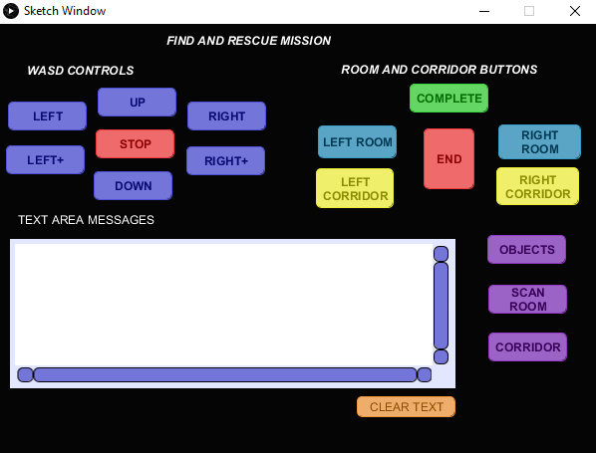
These images show my GUI and my github desktop with all my commits shown on the left hand side.